­­

**Track Document Field Edits by Reviewer**

March 28, 2017 - Version 5.5

Contents

1 Overview 3

1.1 Supported Versions 3

1.2 Category 3

1.3 Special Considerations 3

2 Deployment 4

2.1 New Installation of application 4

2.2 Upgrading application from a previous version 4

3 Input and Preparation 5

3.1 Populating Object 5

3.2 To Input the Script 6

4 Results of Running 8

4.1 Returned output 8

5 Support **Error! Bookmark not defined.**

6 Disclaimer 8

1. Overview

This solution populates a user field and a date field with the name of the reviewer and the current time stamp each time a specified field is edited. The solution can monitor Single Choice, Multiple Choice, and Yes/No fields.

* 1. Supported Versions

This solution is supported in Relativity versions 8.0 – 9.4.

* 1. Category

This custom solution consists of the following components:

Relativity script that runs at workspace level

Event Handler

Custom Object

Relativity Application

* 1. Special Considerations

When upgrading the application, please make sure to follow the upgrade instructions.

The **Reviewed By** and **Reviewed On** fields are not created upon application import. These fields must be created per **Field to Monitor**.

If a user is deleted, they will not be searchable by filtering the view via the **User** field despite seeing the field populated at the document level.

The event handler will be triggered only on the **Save** or **Save & Next** actions, and therefore will not apply to Mass Edit operations.

The **User** field will show up blank in the layout if the field is modified by a system admin, however, the field is populated with the correct information and can be seen in a view.

A **Field to Monitor** should only be added once to the Document Field Edits Tracker object.

An audit record is only created when the **Reviewed By** and **Reviewed On** fields are on the layout. They are not created when these fields are updated by the script.

The Event Handler does not track mass edits or propagation.

* This solution does not support Multitenancy and Data Grid features of Relativity.

Custom components may not exhibit the same performance and behavior as native Relativity features.

While each solution is carefully built and thoroughly tested to work on your version of Relativity, they are not considered core features and are not eligible for the same level of support as the Relativity platform.

1. Deployment
   1. New Installation of application

Log into Relativity.

Navigate to the **Admin/Home** level.

Click on the **Application Library** tab.

Click the **Upload Application** button.

Click the **Browse** button.

Select the **Track Document Field Edits by Reviewer.xml** file and click the **Open** button.

Click the **Save** button.

To install the solution to a Workspace, click the **Install** button in the **Workspaces Installed** category.

In the **Workspaces** field, click the “…” button to select which workspaces to deploy the application to.

Click the **Save** button.

After refreshing the page, the **Workspaces Installed** category will display the progress of the installation.

Navigate to the workspace and create the following fields:

* 1. Create a **Reviewed By** field which is of type User per **Field to Monitor.**
  2. Create a **Reviewed On** field which is of type Date per **Field to Monitor.**
  3. Upgrading application from a previous version

1. Log into Relativity.
2. Go to **Admin/Home** section.
3. Go to **Application Library**.
4. Click on **Track Document Field Edits by Reviewer**.
5. Click **Edit**.
6. Click **Clear** to clear the Application File.
7. Browse to the new Application File and Click **Save**.
8. If it asks to update workspaces automatically, click **Yes**.
9. Ensure the **Application Deployment Manager** agent is running.
10. Ensure the application has installed in all workspaces.
11. This application should not be used to upgrade from a version prior to and including version 3.2. This functionality is not supported, and you may experience errors.
12. Input and Preparation
    1. Populating Object
13. Go to the **Track Document Field Edits by Reviewer** tab.
14. Navigate to its child tab **Document Field Edits Tracker**.
15. Click on the **New Document Field Edits Tracker** button.
    1. **Field To Monitor**
       1. Required
       2. Single Choice
       3. When the selected **Field To Monitor** is edited by a reviewer in a document, the **Reviewed By User** and **Reviewed On Date** fields will be updated with the user who edited the field.
    2. **Reviewed On Date Field**
       1. Required
       2. Date
       3. Single Choice
       4. Select a date field to capture the date and time the **Field To Monitor** was edited by a reviewer.
    3. **Reviewed By User Field**
       1. Required
       2. User
       3. Single Choice
       4. Select a user field to capture the user who edited the Field To Monitor
16. **Track Initial Change Only?**
    * 1. Required
      2. Checkbox
      3. If **Track Initial Change Only?** is set to **Yes**, then the **Reviewed On Date** and **Reviewed by User** fields will only be updated when they have not previously been set for the document.
      4. If **Track Initial Change Only?** is set to **No**, then every time the **Field To Monitor** is edited, the **Reviewed On Date** and **Reviewed By User** fields will be updated for the document.
17. Click **Save**.

**Inputs to the Object**

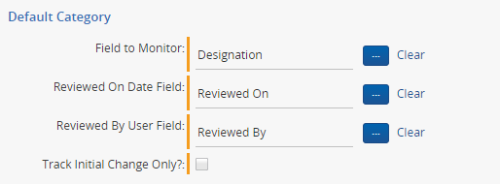

* 1. To Input the Script

If review was started before the application was setup in the workspace, you can use a script to initially populate the **Reviewed By User** and **Reviewed On Date** fields for historical data.

1. Go to the **Administration > Scripts** tab.
2. Locate the script **Populate Reviewed By/On** fieldsfor Historical Edits.
3. Click **Run**.
4. Select your inputs.
   1. **Saved Search**
      1. Required
      2. Select the saved search which will contain the group of documents the script will be executed against.
   2. **Field to Monitor**
      1. Required
      2. Single Choice, Multiple Choice, or Yes/No
   3. **Reviewed By User Field**
      1. Required
      2. User
   4. **Reviewed On Date Field**
      1. Required
      2. Date
   5. **Track Initial Change Only?**
      1. Required
      2. Yes/No
      3. Choose whether or not to only track the first time a field in the document was edited.
5. Click **Run**.
   1. When the script is run, it will populate the selected **Reviewed By User** field and **Reviewed On Date** field based on when the **Field to Monitor** was edited
      1. If the **Track Initial Change Only** input is set to **Yes**, the selected **Reviewed By User** and **Reviewed On Date** fields will be updated with the first edit that was made on the document in the selected field.
      2. If the **Track Initial Change Only** input is set to **No**, the selected **Reviewed By User** and **Reviewed On Date** fields will be updated with the last edit that was made on the document in the selected field.

**Inputs to Script**

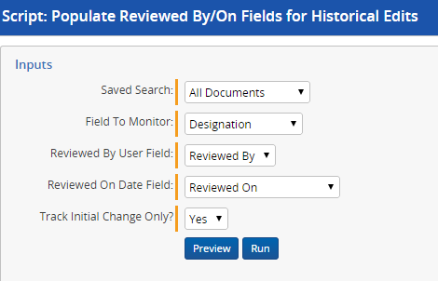

1. Results of Running

If successfully run, the script will return the message “Update Complete.”

* 1. Returned output

To view the results of the solution, navigate to your workspace to see the updated fields.

**Screenshot of Results**

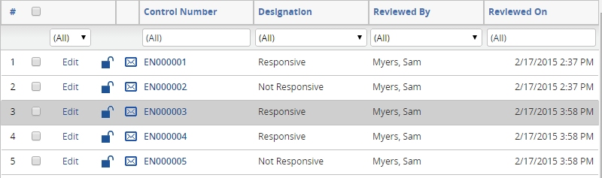

1. Disclaimer

This script is intended for use only in the Relativity versions specified in this document and run under the guidelines presented. While each solution is carefully built and thoroughly tested to work on the versions of Relativity specified in this document, this script is not a core feature of Relativity and is not eligible for the same level of support as the Relativity platform.

In addition, custom components may not exhibit the same performance and behavior as native Relativity features. Custom solutions do not specify permission settings unless explicitly requested by the client.